***____________________________validasi______________________________***

**Nama : Muhamad Wahyu Saputra**

**Kelas : XII RPL B**

**Absen : 34**

**Modul 11**

* **Ketika data belum terisi**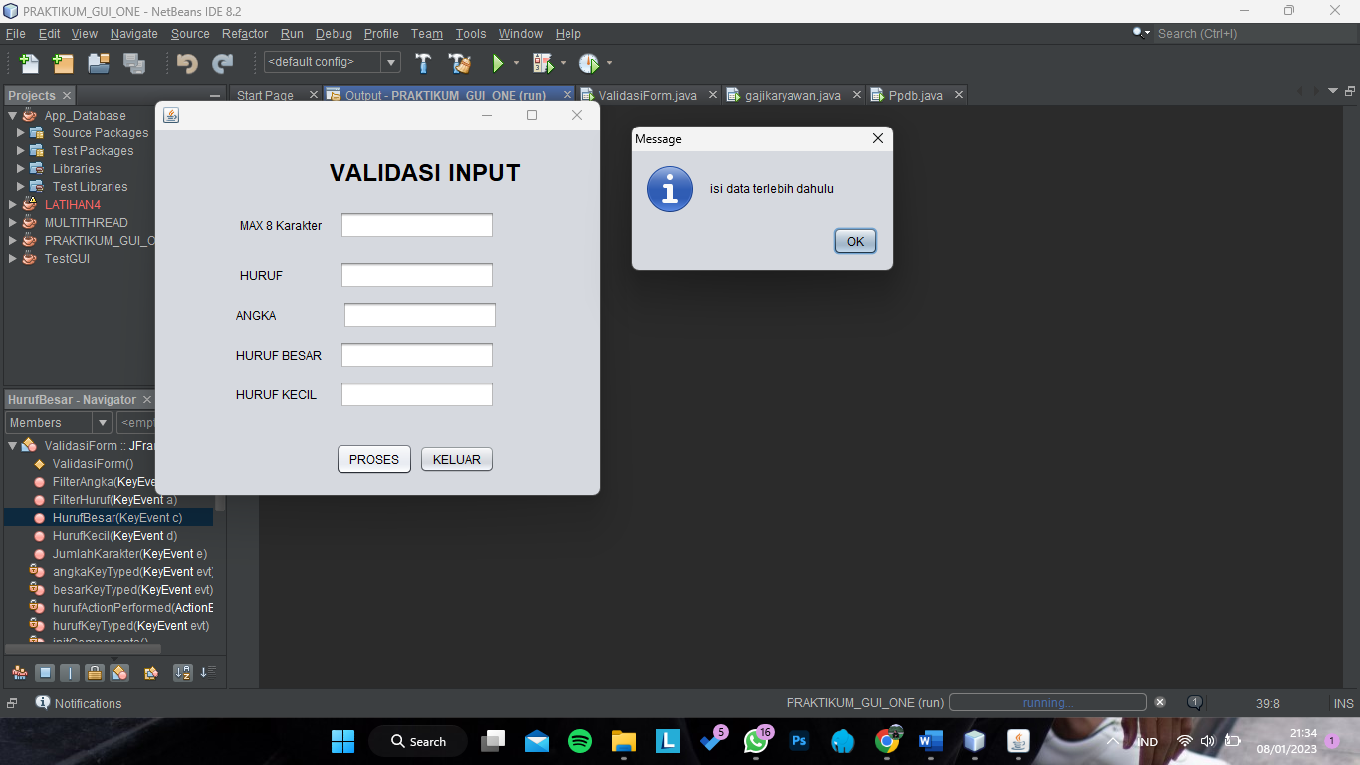
* **Pembatasan jumlah character**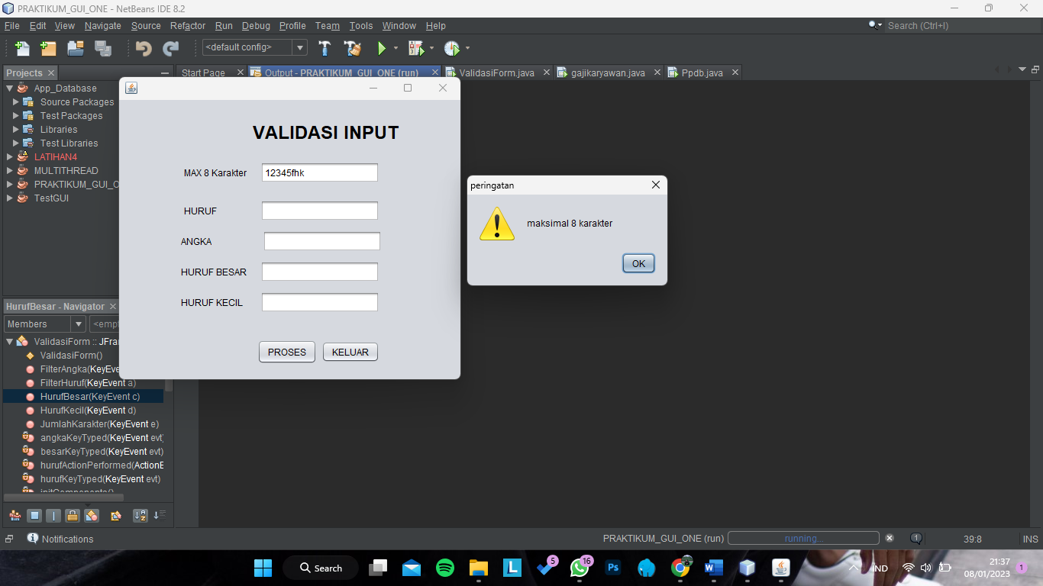
* 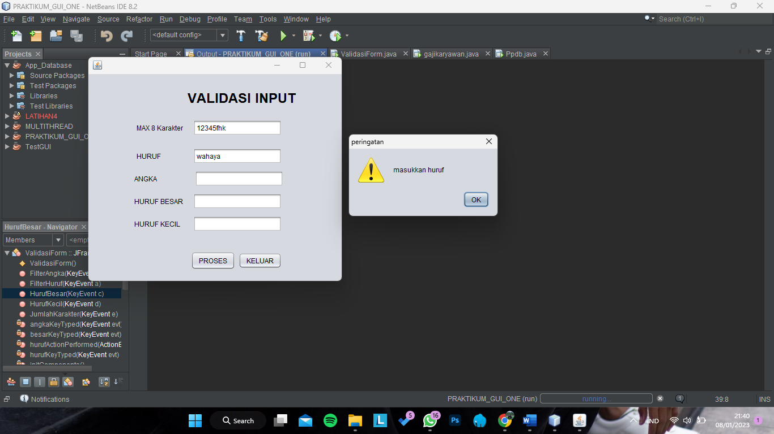**Pembatasan Hanya Huruf**
* **Pembatasan Angka**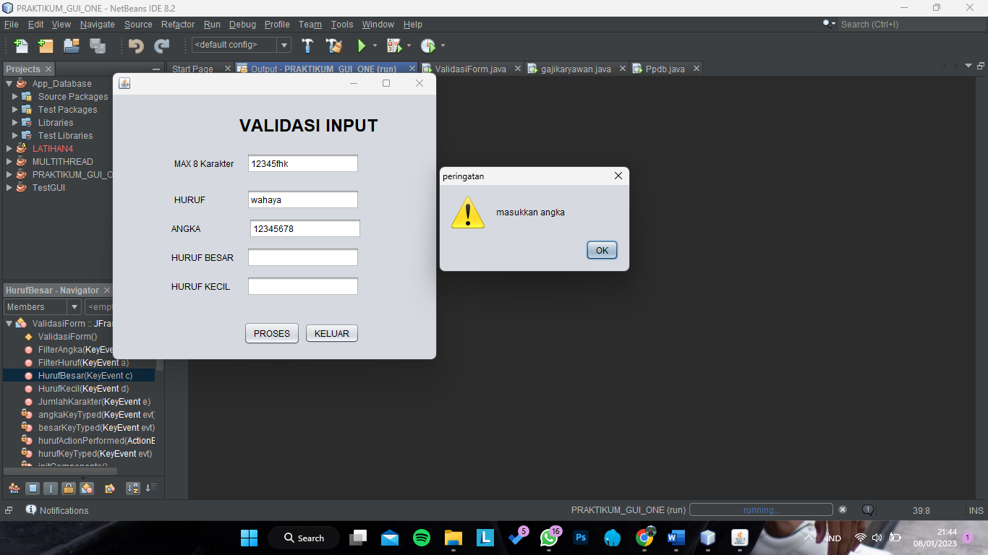
* **Hanya Huruf Besar**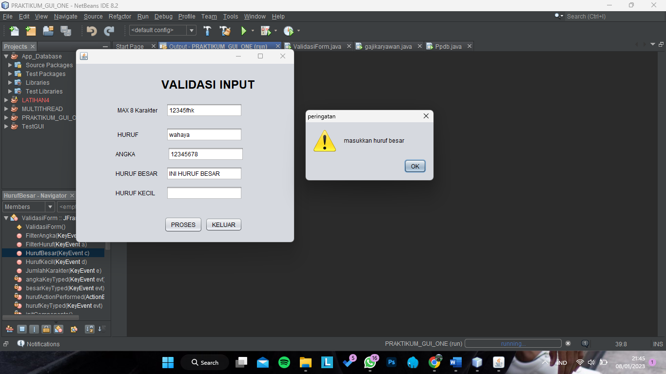
* **Hanya Huruf Kecil**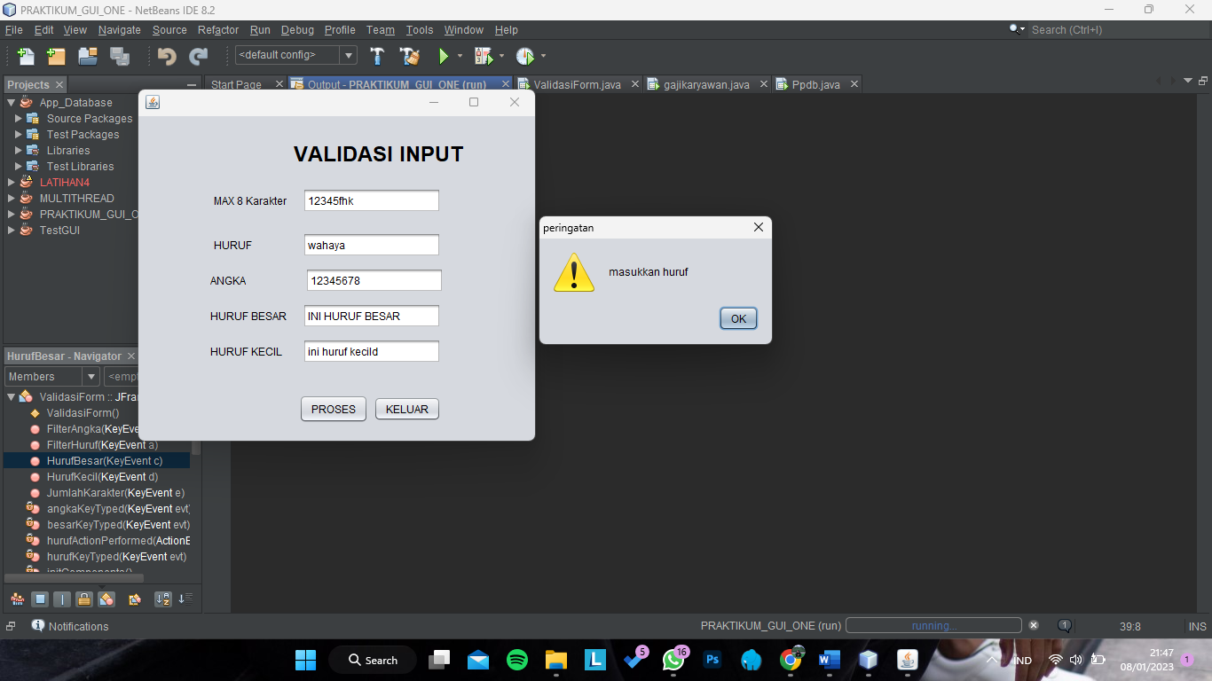

**Tugas 1**

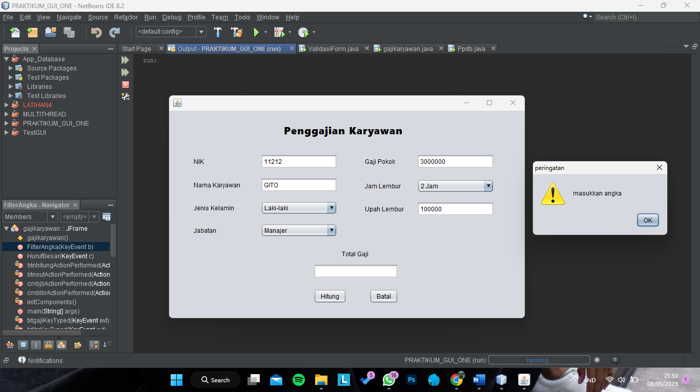

**Tugas 2**

